World Map Review
Directions: Label the features listed below on this world map. Follow the directions in the boxes.
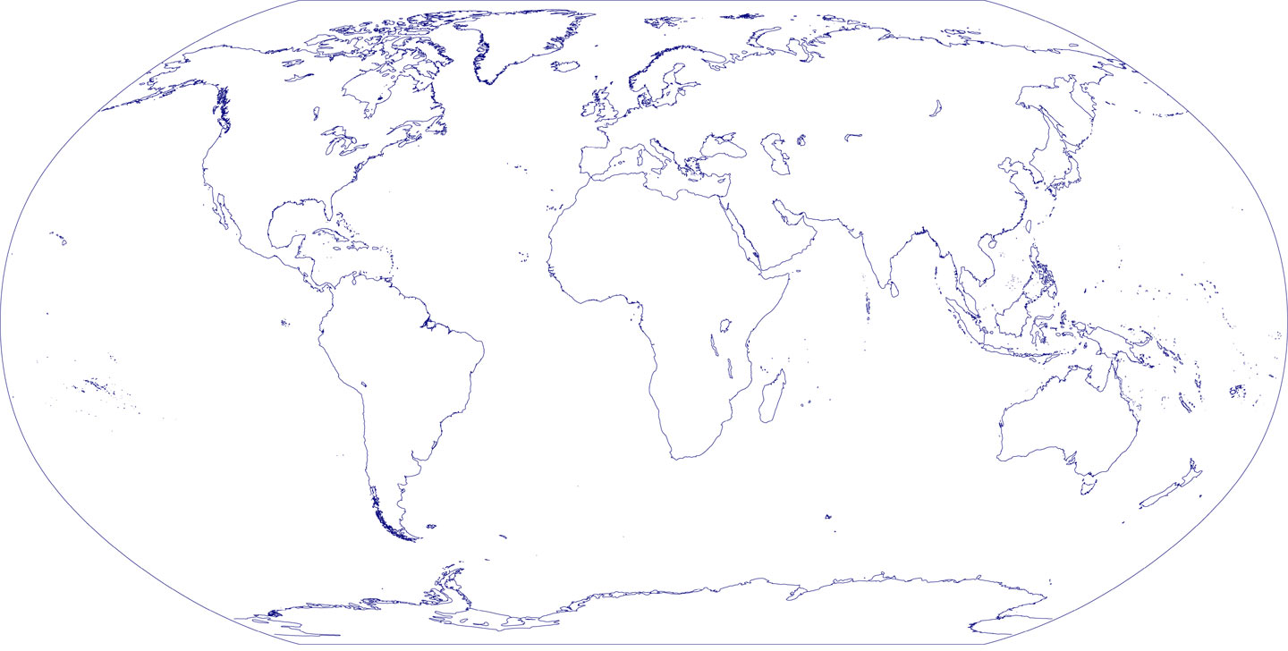
Continents  (Shade each continent a different color) | Oceans  (Create a symbol for each ocean) | Lines of Latitude and Longitude  (Trace these with a dotted line, and label them)
North America  South America  Europe  Africa  Asia  Australia  Antarctica | Atlantic  Pacific  Indian  Arctic  Southern | Equator  Prime Meridian

Use pages H4-H13 to answer the following questions.

- What is a continent? How is a continent different from a country?

- What are lines of latitude and longitude used for?

- What is the Prime Meridian? What is the Equator?

- What is a hemisphere? Which hemisphere(s) do we live in?

- What is a map projection? What problems do all map projections have?

- Pg. H10 lists 5 essential parts of a map. List them, then explain which one you think is the most important.

